Pet Store Multiplication Boxes

The pet shop keeps 7 dogs in each of the 3 pens. How many dogs?
Unit | Pens | Dogs per pen | Dogs
Numbers



The pet shop keeps 9 fish in each of the 9 tanks. How many fish?
Unit | tanks | Fish per Tank | Fish
Numbers

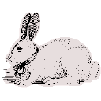
The pet shop keeps 4 rabbits in each of the 4 cages. How many rabbits?
Unit | cages | Rabbits per Cage | Fish
Numbers

